MTSAS Lanyard Inspection Guide

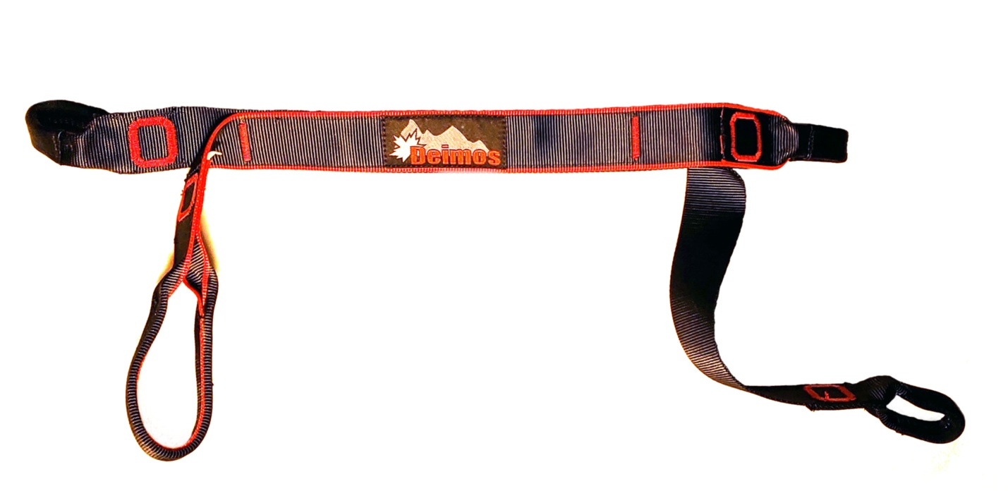

**Retire the MTSAS lanyard if:**

1. If the age of the lanyard is more than 10 years – see the purchase order date.
2. If the lanyard has been in contact with bodily fluids then it must be retired immediately (do not try to clean it).
3. If the lanyard has been cut or ripped.
4. If the lanyard show significant UV damage.
5. If the stitching is starting to open.
6. If the protective black tubular webbing is damaged and you can see the inside material.